**Q.1** The following table indicates the various tasks involved in completing a software project, the corresponding activities, and the estimated duration for each task in months. The precedence relation Ti ≤ {Tj, Tk} implies that the task Ti must complete before either task Tj or Tk can start. The following precedence relation is known to hold among.

|  |  |  |  |
| --- | --- | --- | --- |
| Task | Duration | ES | EF |
| Requirement’s  specification | 1 | 0 | 1 |
| Design | 2 | 1 | 3 |
| Code actuator interface module | 2 | 3 | 5 |
| Code sensor interface module | 5 | 3 | 8 |
| Code user interface part | 3 | 3 | 6 |
| Code control processing part | 1 | 3 | 4 |
| Integrate and test | 6 | 8 | 14 |
| Write user manual | 3 | 0 | 3 |

1. Draw the Activity network representation of the tasks.
2. Determine ES, EF and LS, LF for every task using CPM.
3. Show the critical path using CPM.
4. Develop the Gantt chart representations for the project.

Ans:

Firstly, we will calculate the EF, ES, LS, LF and then slack times (ST).

Here is the Activity Network Diagram:

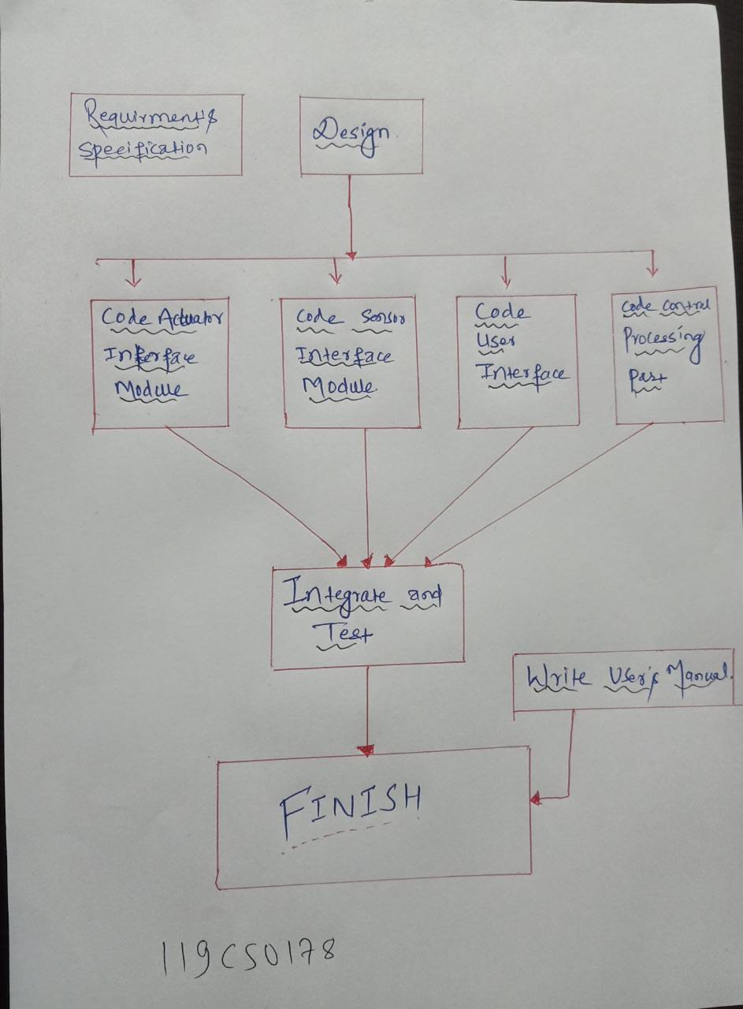

**Now table to calculate ES and EF:**

|  |  |  |  |
| --- | --- | --- | --- |
| Task | Duration | ES | EF |
| Requirement’s  specification | 1 | 0 | 1 |
| Design | 2 | 1 | 3 |
| Code actuator interface module | 2 | 3 | 5 |
| Code sensor interface module | 5 | 3 | 8 |
| Code user interface part | 3 | 3 | 6 |
| Code control processing part | 1 | 3 | 4 |
| Integrate and test | 6 | 8 | 14 |
| Write user manual | 3 | 0 | 3 |

**Now table to calculate LS and LF:**

|  |  |  |  |
| --- | --- | --- | --- |
| Task | Duration | LS | LF |
| Requirement’s  specification | 1 | 0 | 1 |
| Design | 2 | 1 | 3 |
| Code actuator interface module | 2 | 6 | 8 |
| Code sensor interface module | 5 | 3 | 8 |
| Code user interface part | 3 | 5 | 8 |
| Code control processing part | 1 | 7 | 8 |
| Integrate and test | 6 | 8 | 14 |
| Write user manual | 3 | 11 | 14 |

**Now we will create table to calculate slack times (ST):**

|  |  |  |  |  |  |  |
| --- | --- | --- | --- | --- | --- | --- |
| Task | Duration | ES | EF | LS | LF | ST |
| Requirement’s  specification | 1 | 0 | 1 | 0 | 1 | 0 |
| Design | 2 | 1 | 3 | 1 | 3 | 0 |
| Code actuator interface module | 2 | 3 | 5 | 6 | 8 | 3 |
| Code sensor interface module | 5 | 3 | 8 | 3 | 8 | 0 |
| Code user interface part | 3 | 3 | 6 | 5 | 8 | 2 |
| Code control processing part | 1 | 3 | 4 | 7 | 8 | 4 |
| Integrate and test | 6 | 8 | 14 | 8 | 14 | 0 |
| Write user manual | 3 | 0 | 3 | 11 | 14 | 11 |

C)

Critical Path is:

Requirement’s Specification →Code sensor Interface → Integrate and Test → Finish OR

T1 → T4 → T7 → FINISH

**D) Gantt chart:**

